**CSE 2016 - Software Engineering Laboratory**

**ONLINE FASHOIN STORE**

**Prepared by:**

**ROICE VITHAYATHIL (20BCB7064) LEAD**

**K. LAKSHMI NARASIMHA REDDY (20BCB7069)**

**N. VISHNU PRABHAS REDDY (20BCB7103)**

**LAB 10**

**02-10-2021**

<html>

<head>

<meta charset="UTF-8">

<title center>Closet</title>

<link rel="icon"href="logo1.png"/>

<link rel="stylesheet" href="style.css">

<link rel="author"href="page1.html">

<head/>

<body>

<div class="login-box">

<img src="ava.png" class="ava">

<h1>Login</h1>

<form>

<p>Email</p>

<input type="text"name="Email" placeholder="Enter Email ID">

<p>password</p>

<input type="text"name="password" placeholder="password"><br><br>

<center>

<a href="page1.html" class="button">Login</a><br>

<a

href="#">Forgetpassword</a>

</center>

</form>

</div>

<body/>

<html>

Css

body{

background: url(bed%201.jpg);

background-size: 1600px 800px;

background-position: center;

background-repeat: no-repeat;

font-family: sans-serif;

}

.login-box{

width: 420px;

height: 420px;

background: rgba(0, 0,0,0.5);

color: #fff;

top: 40%;

left: 50%;

position: absolute;

transform: translate(-50%,-50%);

box-sizing: border-box;

padding:70px 30px;

}

h1{

margin: 0;

padding:0 0 20px;

text-align: center;

font-size: 22px;

}

.login-box p{

margin: 0;

padding: 0;

font-weight: bold;

}

.login-box input{

width: 100%;

margin-bottom: 20px;

}

.login-box input[type="text"],input[type="password"]

{

border: none;

border-bottom: 2px solid #fff;

background: transparent;

outline: none;

height: 40px;

color: #fff;

font-size: 16px;

}

.ava{

height:100px;

width:100px;

border-radius: 40%;

position: absolute;

top: -30px;

left:calc(50% - 50px);

}

.button{

display: inline-block;

background: #ff523b;

color: #fff;

padding: 8px 30px;

margin: 30px 0;

border-radius: 30px;

transition: background;

}

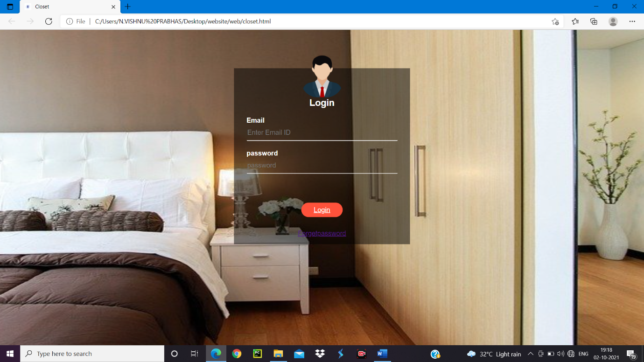

Page 1

<html lang="en">

<head>

<mata charset="UTF-8">

<title>Closet</title>

<link rel="icon"href="logo1.png"/>

<link rel="stylesheet" href="main.css">

<link rel="stylesheet" href="https://cdn.jsdelivr.net/npm/@fortawesome/fontawesome-free@5.15.4/css/fontawesome.min.css">

<head/>

<body>

<div class="fullcolor">

<div class="container">

<div class="navbar">

<div class="logo1">

<img src="logo1.png" width="150px" height="90px">

</div>

<nav>

<ul>

<li><a href="" class="button">Home</a></li>

<li><a href="" class="button">About</a></li>

<li><a href="" class="button">Contact</a></li>

<li><a href="closet.html" class="button">Login</a></li>

</ul>

</nav>

<img src="https://img.icons8.com/ios-filled/50/000000/menu--v1.png" class="menu-icon">

</div>

<div class="header">

<div class="row">

<div class="col-2">

<h1>shop at the<br>best destination for fashion</h1>

<p></p>

<div class="point">

<li><a harf="" class="button">Explore Now &#8594;</a></li>

</div>

</div>

<div class="col-2">

<img src="D.png">

</div>

</div>

</div>

</div>

</div>

<!----->

<div class="categories">

<div class="small-container">

<div class="row">

<div class="col-3">

<img src="image/jeans-1234687_640.jpg" height="400px" width="300px">

</div>

<div class="col-3">

<img src="image/shirt-2604757_640.jpg" height="400px" width="300px">

</div>

<div class="col-3">

<img src="image/title-1587325_640.jpg" height="400px" width="300px">

</div>

</div>

</div>

</div>

<!---prodect-->

<div class="small-container">

<center>

<h2 class="title">confused on what to Buy</h2>

</center>

<div class="row">

<div class="col-4">

<img src="image/sandil.jpg" width="427px" height="280px">

<h4>Red sandles</h4>

<p>Rs2199</p>

<a href="page2.html" class="button">Buy Now</a>

<div class="rating">

<i class="fas fa-star"></i>

<i class="fas fa-star"></i>

<i class="fas fa-star"></i>

<i class="fas fa-star"></i>

<i class="far fa-star"></i>

</div>

</div>

<div class="col-4">

<img src="image/woman-3083383_640.jpg" width="427px" height="280px" >

<h4>shirt for woman</h4>

<p>Rs.1299</p>

<a href="page3.html" class="button">Buy Now</a>

<div class="rating">

<i class="fas fa-star"></i>

<i class="fas fa-star"></i>

<i class="fas fa-star"></i>

<i class="fas fa-star-o"></i>

<i class="far fa-star-o"></i>

</div>

</div><div class="col-4">

<img src="image/feet-1840619_640.jpg"

width="427px" height="280px">

<h4>nike shoes</h4>

<p>Rs.9000</p>

<a href="page4.html" class="button">Buy Now</a>

<div class="rating">

<i class="fas fa-star"></i>

<i class="fas fa-star"></i>

<i class="fas fa-star"></i>

<i class="fas fa-star"></i>

<i class="far fa-star"></i>

</div>

</div><div class="col-4">

<img src="image/shoes-1897708_640.jpg" width="427px" height="280px">

<h4>shoes</h4>

<p>Rs.8000</p>

<li><a href="page5.html" class="button">Buy Now</a></li>

<div class="rating">

<i class="fas fa-star"></i>

<i class="fas fa-star"></i>

<i class="fas fa-star"></i>

<i class="fas fa-star"></i>

<i class="fas fa-star-o"></i>

</div>

</div>

</div>

<center>

<h2 class="title">Latest Products</h2>

</center>

<!--first line--->

<div class="row">

<div class="col-4">

<img src="image/t-shirt-2068353_640.png" width="427px" height="280px">

<h4>blue sweatshirt</h4>

<p>Rs.1298</p>

<li><a href="page6.html" class="button">Buy Now</a></li>

<div class="rating">

<i class="fas fa-star"></i>

<i class="fas fa-star"></i>

<i class="fas fa-star"></i>

<i class="fas fa-star"></i>

<i class="far fa-star"></i>

</div>

</div>

<div class="col-4">

<img src="image/john-torcasio-TJrkkhdB39E-unsplash.jpg" width="427px" height="280px" >

<h4>wrist watch</h4>

<p>Rs.18000</p>

<li><a href="page7.html" class="button">Buy Now</a></li>

<div class="rating">

<i class="fas fa-star"></i>

<i class="fas fa-star"></i>

<i class="fas fa-star"></i>

<i class="fas fa-star-o"></i>

<i class="far fa-star-o"></i>

</div>

</div><div class="col-4">

<img src="image/revolt-164_6wVEHfI-unsplash.jpg"

width="427px" height="280px">

<h4>Nike red shoes</h4>

<p>Rs.8000</p>

<li><a href="" class="button">Buy Now</a></li>

<div class="rating">

<i class="fas fa-star"></i>

<i class="fas fa-star"></i>

<i class="fas fa-star"></i>

<i class="fas fa-star"></i>

<i class="far fa-star"></i>

</div>

</div><div class="col-4">

<img src="image/radek-skrzypczak-WlB8TsI_th0-unsplash.jpg" width="427px" height="280px">

<h4>Brown leather shoes</h4>

<p>Rs.6000</p>

<li><a href="" class="button">Buy Now</a></li>

<div class="rating">

<i class="fas fa-star"></i>

<i class="fas fa-star"></i>

<i class="fas fa-star"></i>

<i class="fas fa-star"></i>

<i class="fas fa-star-o"></i>

</div>

</div>

</div>

<!--second line--->

<div class="row">

<div class="col-4">

<img src="image/jaelynn-castillo-xfNeB1stZ_0-unsplash.jpg" width="427px" height="280px">

<h4>women's wrist ware</h4>

<p>Rs.7998</p>

<li><a href="" class="button">Buy Now</a></li>

<div class="rating">

<i class="fas fa-star"></i>

<i class="fas fa-star"></i>

<i class="fas fa-star"></i>

<i class="fas fa-star"></i>

<i class="far fa-star"></i>

</div>

</div>

<div class="col-4">

<img src="image/pixel-bee-u8isJQ6QjF4-unsplash.jpg" width="427px" height="280px" >

<h4>Rolex watch</h4>

<p>Rs.13999</p>

<li><a href="" class="button">Buy Now</a></li>

<div class="rating">

<i class="fas fa-star"></i>

<i class="fas fa-star"></i>

<i class="fas fa-star"></i>

<i class="fas fa-star-o"></i>

<i class="far fa-star-o"></i>

</div>

</div><div class="col-4">

<img src="image/shoes-153310_640.png"

width="427px" height="280px">

<h4>converse shoes</h4>

<p>Rs.15000</p>

<li><a href="" class="button">Buy Now</a></li>

<div class="rating">

<i class="fas fa-star"></i>

<i class="fas fa-star"></i>

<i class="fas fa-star"></i>

<i class="fas fa-star"></i>

<i class="far fa-star"></i>

</div>

</div><div class="col-4">

<img src="image/wengang-zhai-_fOL6ebfECQ-unsplash.jpg" width="427px" height="280px">

<h4>red shoes</h4>

<p>Rs.9998</p>

<li><a href="" class="button">Buy Now</a></li>

<div class="rating">

<i class="fas fa-star"></i>

<i class="fas fa-star"></i>

<i class="fas fa-star"></i>

<i class="fas fa-star"></i>

<i class="fas fa-star-o"></i>

</div>

</div>

</div>

<!---third---->

<div class="row">

<div class="col-4">

<img src="image/benjamin-rascoe-SZoTel1Y4qc-unsplash.jpg" width="427px" height="280px">

<h4>three piece for men</h4>

<p>Rs.15998</p>

<li><a href="" class="button">Buy Now</a></li>

<div class="rating">

<i class="fas fa-star"></i>

<i class="fas fa-star"></i>

<i class="fas fa-star"></i>

<i class="fas fa-star"></i>

<i class="far fa-star"></i>

</div>

</div>

<div class="col-4">

<img src="image/benjamin-rascoe-Z3N7m_r02TA-unsplash.jpg" width="427px" height="280px" >

<h4>suit for men</h4>

<p>Rs.12000</p>

<li><a href="" class="button">Buy Now</a></li>

<div class="rating">

<i class="fas fa-star"></i>

<i class="fas fa-star"></i>

<i class="fas fa-star"></i>

<i class="fas fa-star-o"></i>

<i class="far fa-star-o"></i>

</div>

</div><div class="col-4">

<img src="image/shirt-2605698_640.jpg"

width="427px" height="280px">

<h4>white shirt</h4>

<p>Rs.1899</p>

<li><a href="" class="button">Buy Now</a></li>

<div class="rating">

<i class="fas fa-star"></i>

<i class="fas fa-star"></i>

<i class="fas fa-star-o"></i>

<i class="fas fa-star-o"></i>

<i class="far fa-star-o"></i>

</div>

</div><div class="col-4">

<img src="image/santhosh-kumar-RqYTuWkTdEs-unsplash.jpg" width="427px" height="280px">

<h4>shirt</h4>

<p>Rs.2000</p>

<li><a href="" class="button">Buy Now</a></li>

<div class="rating">

<i class="fas fa-star"></i>

<i class="fas fa-star"></i>

<i class="fas fa-star"></i>

<i class="fas fa-star-o"></i>

<i class="fas fa-star-o"></i>

</div>

</div>

</div>

<center>

<h2 class="title">T-Shirts</h2>

</center>

<div class="row">

<div class="col-4">

<img src="image/alex-haigh-fEt6Wd4t4j0-unsplash.jpg" width="427px" height="280px">

<h4>T-shirt</h4>

<p>Rs500</p>

<li><a href="" class="button">Buy Now</a></li>

<div class="rating">

<i class="fas fa-star"></i>

<i class="fas fa-star"></i>

<i class="fas fa-star"></i>

<i class="fas fa-star"></i>

<i class="far fa-star-o"></i>

</div>

</div>

<div class="col-4">

<img src="image/ryan-hoffman-6Nub980bI3I-unsplash.jpg" width="427px" height="280px" >

<h4>Black shirt</h4>

<p>Rs.800</p>

<li><a href="" class="button">Buy Now</a></li>

<div class="rating">

<i class="fas fa-star"></i>

<i class="fas fa-star"></i>

<i class="fas fa-star"></i>

<i class="fas fa-star"></i>

<i class="far fa-star-o"></i>

</div>

</div><div class="col-4">

<img src="image/florencia-simonini-PDZAMYvduVk-unsplash.jpg"

width="427px" height="280px">

<h4>white T-shirt</h4>

<p>Rs.900</p>

<li><a href="" class="button">Buy Now</a></li>

<div class="rating">

<i class="fas fa-star"></i>

<i class="fas fa-star"></i>

<i class="fas fa-star"></i>

<i class="fas fa-star"></i>

<i class="far fa-star-o"></i>

</div>

</div><div class="col-4">

<img src="image/faith-yarn-Wr0TpKqf26s-unsplash.jpg" width="427px" height="280px">

<h4>stylish black T-shirt</h4>

<p>Rs.800</p>

<li><a href="" class="button">Buy Now</a></li>

<div class="rating">

<i class="fas fa-star"></i>

<i class="fas fa-star"></i>

<i class="fas fa-star"></i>

<i class="fas fa-star-o"></i>

<i class="fas fa-star-o"></i>

</div>

</div>

</div>

</div>

<body/>

<html/>

Css

*{

margin: 0;

padding: 0;

box-sizing: border-box;

}

.navbar{

display: flex;

align-items: center;

padding-left: 100px;

}

nav{

flex: 1;

text-align: right;

}

nav ul{

display: inline-block;

list-style-type: none;

}

nav ul li{

display: inline-block;

margin-right: 10px;

}

.a{

text-decoration: none;

color: #555;

}

.p{

color: #555;

}

.container{

max-width: 3000px;

margin: auto;

padding-right:1px;

padding-left: 1px;

}

.row{

display: flex;

align-items: center;

flex-wrap: wrap;

justify-content: space-around;

}

.col-2{

flex-basis: 35%;

min-width: 100px;

}

.col-2 img{

max-width: 100%;

padding: 10px 0;

}

.button{

display: inline-block;

background: #ff523b;

color: #fff;

padding: 8px 30px;

margin: 30px 0;

border-radius: 30px;

transition: background;

}

.button:hover{

background: #563535;

}

.header{

background: radial-gradient(#82b74b,#82b74b)

}

.fullcolor{

background: radial-gradient(#fff,#ffd6d6)

}

.point{

list-style-type: none;

display: inline-block;

}

.header .row{

margin-top: 70px;

}

.categories{

margin: 70px 0;

}

.col-3{

flex-basis: 30%;

min-width: 250px;

margin-bottom: 30px;

}

.col-3 img{

width: 100%;

}

.small-container{

max-width: 1080px;

margin: auto;

padding-left: 25px;

padding-right: 25px;

}

.col-4{

flex-basis: 25%;

padding: 10px;

min-width: 200px;

margin-bottom: 50px;

transition: transform 0.5s;

}

.col-4 img{

width: 100%;

}

.title{

margin: 0 auto 80px;

position: relative;

line-height: 60px;

color: #555;

}

.title::after{

content:"";

background: #ff523b;

width: 80px;

height: 5px;

border-radius: 5px;

position: absolute;

bottom: 0;

left: 50%;

transform: translate(-50%);

}

h4{

color: #555;

font-weight: normal;

}

.col-4 p{

font-size: 14px;

}

.col-4:hover{

transform: translateY(-10px);

}

.menu-icon{

width: 28px;

margin-left: 20px;

}

@media only screen and (max-width:800px){

nav ul{

position: absolute;

top:90px;

left: 0;

background: #333;

width: 110px;

}

nav ul li{

display: block;

margin-right: 50px;

margin-top: 10px;

margin-bottom: 10px;

}

}

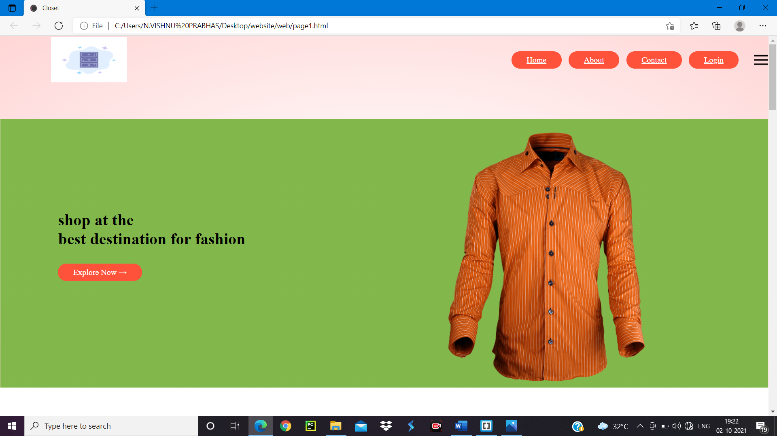

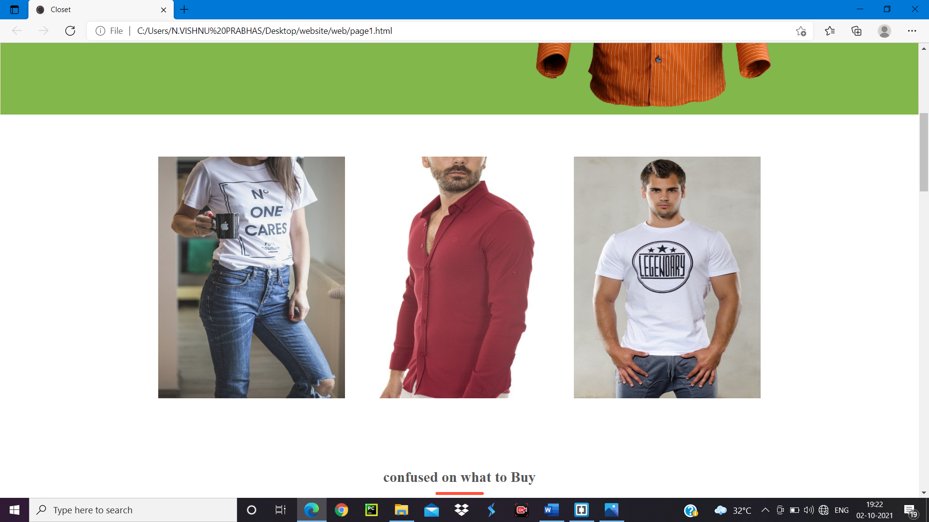

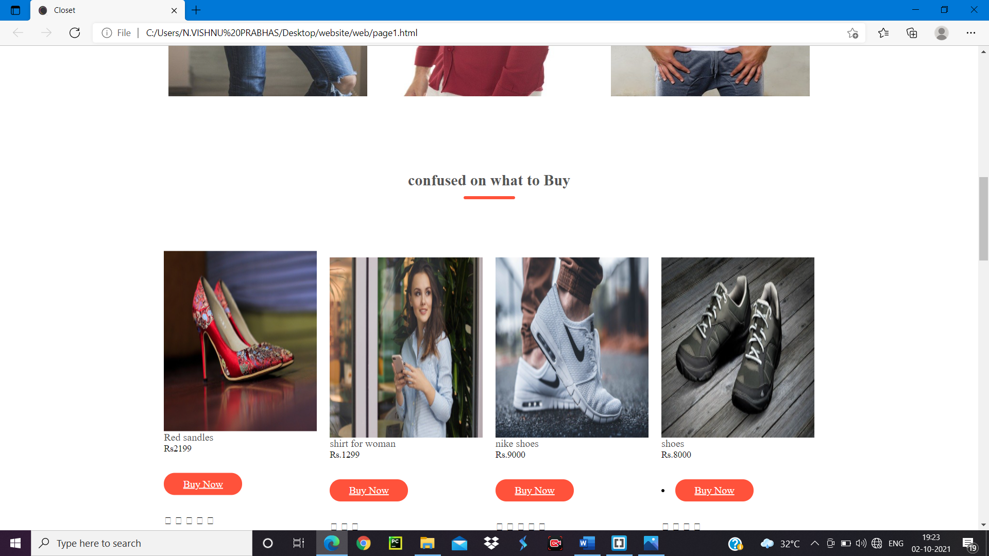

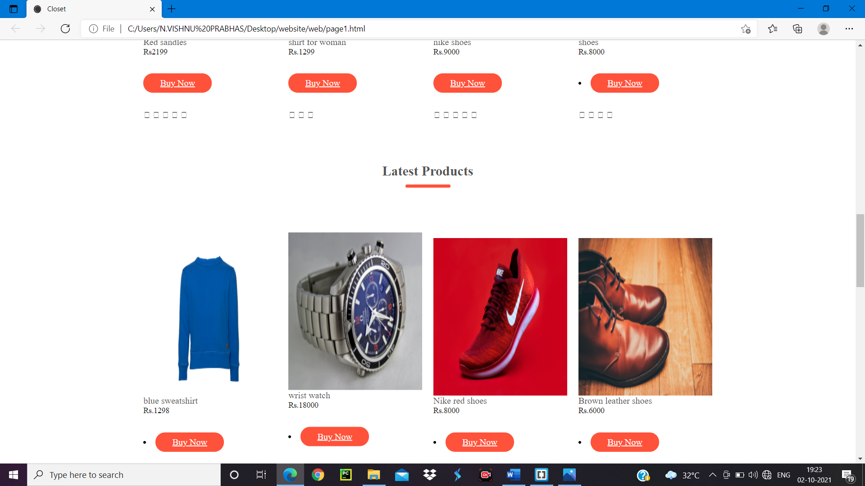

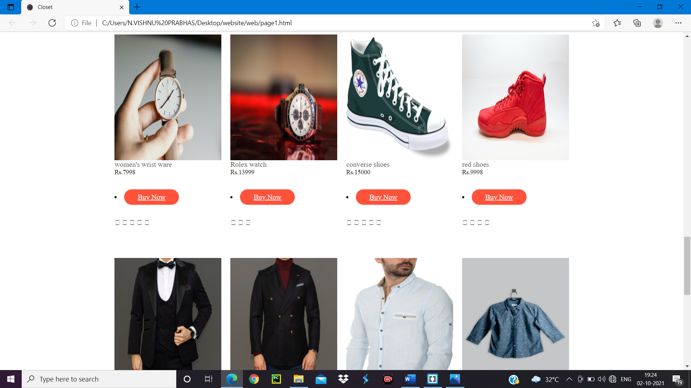

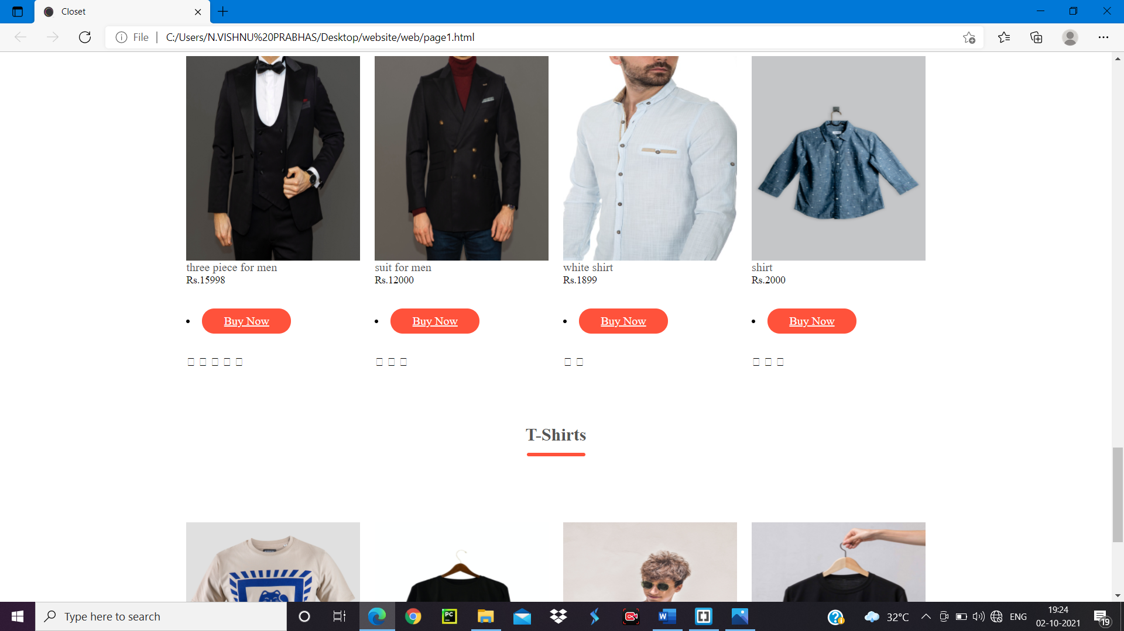

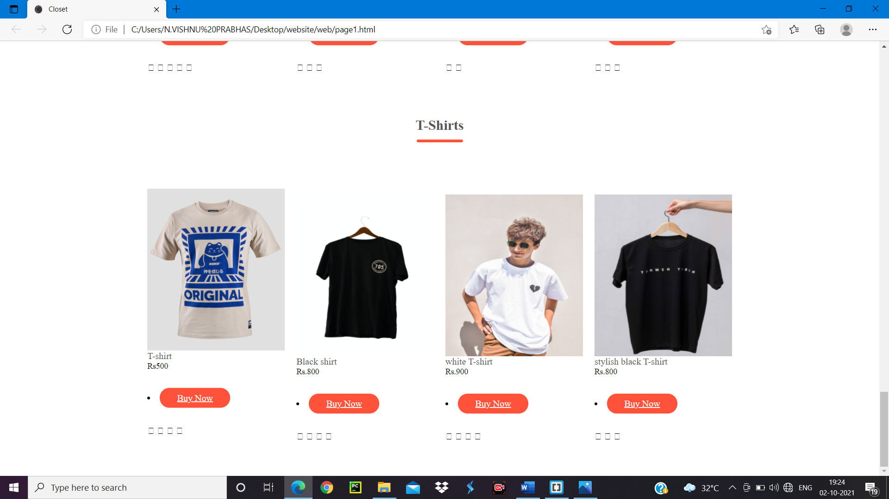

Buy now button pressed

<html lang="en">

<head>

<mata charset="UTF-8">

<title>Closet</title>

<link rel="icon"href="logo1.png"/>

<link rel="stylesheet" href="pg2.css">

<link rel="stylesheet" href="https://cdn.jsdelivr.net/npm/@fortawesome/fontawesome-free@5.15.4/css/fontawesome.min.css">

<head/>

<body>

<div class="navbar">

<div class="logo1">

<img src="logo1.png" width="150px" height="90px">

</div>

<nav>

<ul>

<li><a href="page1.html" class="button">Home</a></li>

<li><a href="" class="button">About</a></li>

<li><a href="" class="button">Contact</a></li>

<li><a href="closet.html" class="button">Login</a></li>

</ul>

</nav>

</div>

<div class="row">

<div class="col">

<img src="image/sandil.jpg">

<h4>Red sandle for women</h4>

<p>Rs2199</p>

</div>

</div>

<div class="custmerdetails">

<center>

<p>First name</p>

<input type="text"name="First name" placeholder="Enter first name">

<p>Last name</p>

<input type="text"name="Last name" placeholder="Enter Last name">

<p>Email</p>

<input type="text"name="Email" placeholder="Enter Email ID">

<p>Phone no</p>

<input type="text"name="Phone no" placeholder="Enter Phone number">

<p>address</p>

<input type="text"name="address" placeholder="Enter the address">

<center>

<a href="" class="button">Submit</a><br>

<a

href="#">Forgetpassword</a>

</center>

</center>

</div>

<body/>

<html/>

Css

*{

margin: 0;

padding: 0;

box-sizing: border-box;

}

.navbar{

display: flex;

align-items: center;

padding: 20px;

}

nav{

flex: 1;

text-align: right;

}

nav ul{

display: inline-block;

list-style-type: none;

}

nav ul li{

display: inline-block;

margin-right: 10px;

}

.a{

text-decoration: none;

color: #555;

}

.p{

color: #555;

}

.row{

display: flex;

align-items: center;

flex-wrap: wrap;

justify-content: space-around;

}

.col{

flex-basis: 35%;

min-width: 100px;

}

.col img{

max-width: 100%;

padding: 10px 0;

}

.button{

display: inline-block;

background: #ff523b;

color: #fff;

padding: 8px 30px;

margin: 30px 0;

border-radius: 30px;

transition: background;

}

.button:hover{

background: #563535;

}

h4{

color: #555;

font-weight: normal;

}

